AREA 3 CONVENTION & CONTEST

MAY 4-6, 2018
BINGHAMTON, NY

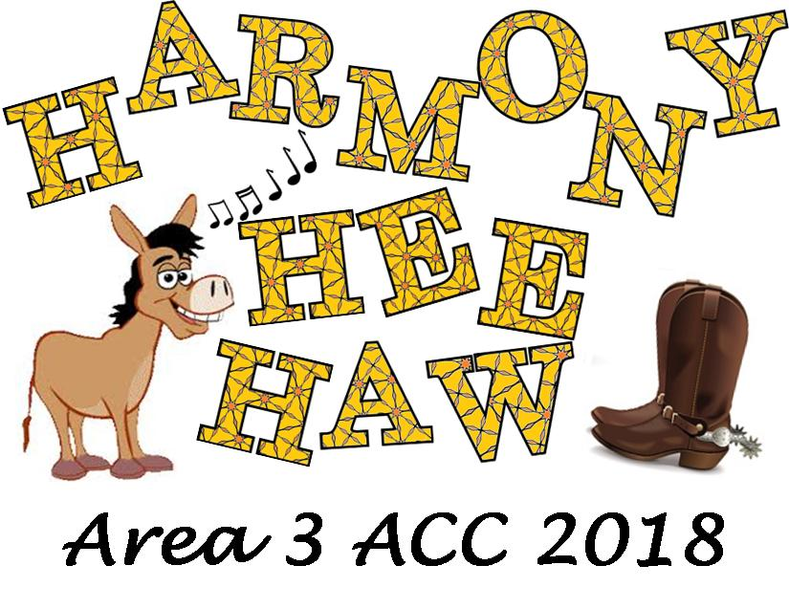

AREA 3’s A.C.C.T. [Area Convention & Contest Team]

and Hostess Chapter, ROCHESTER RHAPSODY,

Welcomes You To:

“HARMONY HEE HAW”

This 1st mailing provides members with important information. Please read fully for details:

*Page 2 = Hotel Information & Housing form

*Page 2 = Contest Registration & AEP form

*Page 3 = Contestant General Information

*Page 4 = TENTATIVE Weekend Schedule & MBHA Information

*Page 5 = Area Chorus / Quarus / Family Song Information

*Page 6 = Hostess Chapter Information

*Page 7 = Moonglow / Program Ads

More details will follow in the 2nd mailing in early April. Questions? Please email BOTH General Co-Chairs:

Sue & Dorene at: acct@area3harmony.org

----------------------------------------------------------------------------------------------------------------------

AC&C 2018 HOUSING
Please complete & return an email copy, if mailing a hard copy, it must be postmarked by MARCH 15, 2018
to: Denise Michaelsen, 1669 Erie Station Road, Henrietta, NY 14467
[email: facilities@area3harmony.org]
Hotel: Holiday Inn Binghamton, 2 Hawley Street, Binghamton, NY 13901
$119.00 [single/double] ]+13% tax.
$129.00 [triple] ]+13% tax.
$149.00 [quad]+13% tax.
$179.00 [LIMITED King suites] ]+13% tax.

Individual reservations will NOT be accepted; all rooms MUST be booked through our ACCT Facilities Coordinator, Denise Michaelsen. Please email Denise with questions. Return ONE completed Housing Form ~ please, no handwritten forms [can be very hard to read]. Each chapter/quartet contact must provide a contact email for questions. A list of occupants in each room is required; be sure to indicate any special needs. The form allows for a chapter credit card so, if you are paying with a chapter credit card, this card is needed ONLY to hold the reservation. Reserved cards are imprinted at check in.

NYS choruses may submit a Tax Exempt ST-119 Form (Denise can email that to your chorus Treasurer if needed), along with their Housing form. ALL rooms under the exempt status for that chorus need to be paid by a chapter credit card or cash. A debit card attached to a chorus checking account or cashier’s check is recommended. (NO tax exempt status for individuals.) Parking on-site at the Holiday Inn Binghamton is FREE. There is an on-site restaurant and lounge, and excellent amenities such as an indoor swimming pool, fitness room, & complimentary high speed internet access. Inside the hotel, the Galleria features shops including a hair salon, nail salon, onsite ATM and boutique!
Please, ALL reservations are to include the following information. Thank you!
- Name[s] for all occupants of each room, also include room type.
(single, double, trip/quad). This is a NON-SMOKING HOTEL.
- Credit card type to be used for payment, including number & expiration date – this is required only for the purpose of ‘holding’ the reservation…
- Arrival Date and Departure Date [check-in is 3 p.m., check-out by 11 a.m.].

=================================================================================

AC&C 2018 REGISTRATION [AEP]

Contest Site: Holiday Inn Binghamton, 2 Hawley Street, Binghamton, NY 13901
As last year, our contest location is THE SAME as our HOUSING venue!! Just as we do at IC&C, we are conducting all AC&C 2018 events under one roof!
Please complete & return an email copy, if mailing a hard copy, it must be postmarked by MARCH 15, 2018
to: Michelle Buckenmeyer, 59 Autumn Chapel Way, Rochester, NY 14624,
[email: parliamentarian@area3harmony.org]
Full AEP for AC&C 2017 is $100.00
Non-Performing AEP costs $79.00
Youth AEP will cost $84.00 [again covered by STEVE HEGADORN GRANT]
**AEP prices include Judges Equalization Fee from Harmony Inc. & continue to include $35 MoonGlow dinner!

General Admission tickets can be purchased by Area 3 members that are not performing, family members, friends, or guests for $15.00 per event [$5.00 for Youth guests.] REMEMBER: AEPs are transferable, not refundable. All choruses / associates must complete this form whether or not you are competing.
*PLEASE be certain all registered names are spelled so that AEP badges are accurate. Complete the names in alphabetical order for each member attending, & list the appropriate AEP price. Also include known guest names and money for any tickets being purchased [$15] or dinners [$35]. Note: This allows guest seating with the chorus they register with!
*PLEASE return the Registration Form as an MS Word file. This way, the names and chorus/quartet you are associated with are submitted accurately, and they will be printed on the AEPs exactly as entered on the form! Mail a copy of the form with ONE CHECK as payment, all fees included, to Michelle. All choruses/members are highly encouraged to return their paid AEP Registration Forms as soon as possible!!
*NOTE: Reminder, receipt order of AEP/Registration determines priority MoonGlow seating!*
-2-

----------------------------------------------------------------------------------------------------------------------------------------

AC&C GENERAL CONTESTANT INFORMATION: It's time for all contestants [chorus & quartets] to complete and send in their Contest Entry Forms. Please download the forms (HAR-061 or HAR-063) from the Harmony Inc. website, Members Only section; complete and send with the correct entry fee to the Corporate Office. The mailing address is on Page 2 of the form. A copy of the Contest Entry form is sent electronically from the Corporate Office to Nicola Stevens, Area Contest and Judging Chair (ACJC), in order to complete the draws for order of appearance.

Contest Entry forms must be postmarked no later than March 5, 2018, in order to be a part of the initial draw for the Order of Appearance for either the Quartet or Chorus Contest. If you miss this date, a late fee will be assessed and you will sing first in the applicable contest. In order to compete, your late entry must be postmarked no later than April 4, 2018.

IMPORTANT: Quartet Registration/Renewal was due by January 31st. If you have not already registered, please do so as soon as possible. Please remember that Quartets must be registered with the Corporate Office in order to compete. The Registration/Renewal forms (HAR-028 and HAR-028A) are available on the Harmony Inc. website (www.harmonyinc.org) under the ‘Members Only’ section.

The Judging Panel will be announced soon. This information will be posted on the Area 3 website and included in the 2nd mailing. If you have any questions with regard to either the Chorus or Quartet contest, please contact ACJC Nicola Stevens at a3jc@harmonyinc.org

=================================================================================
Please Note: There will be NO stage curtain. Each chorus package starts when the director signals the emcee for the introduction. Quartet packages begin when the emcee introduces each quartet.

Chorus Photo Change: CHORUS photos will be taken on the stage IMMEDIATELY AFTER your chorus has finished singing. Please plan your photo pose ahead of time, and be prepared to go into that pose immediately after taking your applause. [Quartet photos will still be in a separate room prior to the warm-up room].

Quartet Heads-up: Please note that the Quartet Contest time listed below is tentative. We may have to start slightly earlier depending on the number of quartets competing. We will not know this until all entry forms have been submitted. Please consider coming Thursday night if possible, so you can enjoy contest day without being rushed!
Quartet Heads-up 2: Quartets, please remember that there are no classrooms or warm-up areas, so you will need a hotel room to get ready in. Please don’t leave it until the last minute to figure this out. If possible, try and come Thursday night so you have a room, or see if a chorus member is coming on Thursday who will allow you to use her room.

Mixed Quartet Heads-up: Depending on the number of Quartets competing, the Mixed Quartet evaluations may take place Sunday morning instead of Friday night.
-3-

********************************************************************************************
CONTEST STAGE INFORMATION:
As the Binghamton Holiday Inn is a new venue for our AC&C, Contest Site details will be provided and updated on the Area website when they become available.
*******************************************************************************************

“TENTATIVE” WEEKEND SCHEDULE ~ AC&C May 4-6, 2018
DATE | TIME | SCHEDULE | ROOM/FACILITY
Friday, May 4 | 12 Noon – 3.30PM | Registration | Hotel Hospitality Foyer
 | 10 AM – 1.30PM | Hospitality | Hotel Hospitality Room
 | 1:00 PM – 1:30PM | Area Quarus Rehearsal | Carousel Room
 | 1:30PM – 2PM | Contestant Judges Briefing | Hotel Ballroom
 | 2PM – 2:45 PM | Quartet on-stage viewing | Hotel Ballroom
 | 3:30 PM - 7:00 PM | Quartet Contest: Area Quarus, Awards & Qualifiers, 1st place Quartet sings | Hotel Ballroom
 | 6:45 PM – 8.00 PM | Judges Dinner | Hotel
 | 8.00 PM – 11.00PM | Evaluations | Hotel – Rooms TBA
Saturday, May 5 | 8AM -10:30 AM | Hospitality | Hotel Hospitality Room
 | 9:30 AM – 10AM | Chorus on-stage viewing (no singing) | Hotel – Ballroom
 | 10AM -12 Noon | Registration | Hotel Hospitality Foyer
 | 10AM – 10:30AM | Area Chorus Rehearsal | Hotel Ballroom
 | 10:30AM – 11AM | Family Chorus Rehearsal | Hotel Ballroom
 | 12 Noon – 2:30 PM | Chorus Contest: Area Chorus, Awards & Qualifiers, 1st place Chorus sings | Hotel Ballroom
 | 2:30 PM – 4:30 PM | Chorus Evaluations | Hotel – Rooms TBA
 | 6:30 PM – 8PM | Cocktails / Dinner | Hotel Ballroom
 | 8PM – 10:00PM | MoonGlow | Hotel Ballroom
Sunday, May 6 | 9AM – Noon | Education / Craft Classes | Hotel - Rooms – TBA
 | 9AM – 11AM | Hospitality | Hotel Hospitality Room

NOTE: This is a TENTATIVE SCHEDULE ONLY. The Chairman of Judges (COJ) will give the FINAL approval late April, 2018. AGAIN–these times & locations are NOT final!

========================================================================

Harmony Welcomes Mixed Quartets!

We’re happy to announce that Areas 1, 2, 3, & 6 have opened their arms to include mixed quartets registered with the Mixed Barbershop Harmony Association (MBHA) in this spring’s Area Conventions. These Areas invite mixed quartets of any makeup – MWWW, MMWW, MMMW – to experience the joy of a Harmony convention first hand and to be adjudicated at the AC&C.

For details on how to register with MBHA visit: www.mixedbarbershop.org. Once you are registered with MBHA and your dues are up to date, you may register your quartet for the Area contest through the Quartet Contest Entry Form (HAR-061). Song selections must also be submitted prior to the contest using the Contestant Song Registration Form, [HAR-082]. All contestants must purchase an All Events Pass [AEP] for the Area Contest & Convention. The due date for all Contest Entry Forms is March 5th.

For questions or quartets outside of Harmony, Inc., please contact the Area 3 ACJC –
Nicola Stevens: a3jc@harmonyinc.org.

More information about MBHA can be located on the Area 3 website: www.area3harmony.org

-4-

AREA 3 CHORUS:
Katie Taylor is leading our 2018 Area 3 Chorus in song at this year’s AC&C, as the director from Northern Blend Chorus, our current Area 3 1st Place Champions and 2017 International Championship Chorus! The song is “Thank You For The Music”, arranged by Larry Wright.

Traditionally, the Area Chorus has been made up of 4 singers from each chapter but has not always been limited to that. If you are able to be in the Area 3 Chorus, PLEASE be certain to do your part by LEARNING the song. We will continue with our annual AC&C Saturday morning rehearsal and performance Saturday afternoon at AC&C. Remember that all Area 3 Associate members [in good standing] are also invited to sing in the Area 3 Chorus! The Area 3 Director will send out 4 copies of music and trax to each chorus. Associates and any other member interested in singing may contact Janine Schindler, Area 3 Director at:area3director@harmonyinc.org.

AREA 3 QUARUS:
Our Area 3 Quarus Director for 2018 is Lisa Twitchell, and the song the Quarus will be singing is be singing is, “Eight Days A Week”, arranged by David Harrington. Sheet music and learning trax will be available to registered quartets soon, once you decide that your quartet can learn this song and be with us for the Friday afternoon rehearsal and performance Friday evening at AC&C. Please email the Area 3 Quartet Promotions Coordinator, Lisa Twitchell at: quartets@area3harmony.org for music and trax.

AREA 3 FAMILY CHORUS:
This is an invitation to all Area 3 singers who fall within the FAMILY category to please participate in our Family Chorus at AC&C 2018! This year’s director will be Donna McKay and the song she has chosen is “Fun In One Lifetime”, arranged by Joe Liles. We certainly don’t want to miss anyone who is eligible to enjoy this experience and encourage all members who have a mother, mother-in- law, daughter, daughter-in- law, sister, sister-in- law, aunt, cousin, associate member and/or affiliate male family member that sing in Area 3 – to please join us! It is a very enjoyable and rewarding experience.

Please indicate your interest in participating by emailing Janine Schindler, the Area Director at: area3director@harmonyinc.org, and she will send you the music and trax. We’ll continue with our annual AC&C Saturday morning rehearsal and Saturday performance at AC&C so that we may have some time together prior to our performance.

-5-

AC&C 2018 Hostess Chapter, ROCHESTER RHAPSODY, welcomes you to:

“HARMONY HEE HAW”…

--------------------------------------------------------------------------------------------------------
Attention Area 3!!! Prepare yourself for an amazing hoe down weekend with Rochester Rhapsody, celebrating…
“Harmony Hee Haw”…Whether you’ve driven up yonder a ways or down the road apiece, we’ll all settle in at a new locale. Don yer best britches, colorful neckerchiefs, and yer straw hats, cuz were fixin’ on having a good time. While ya wait, make time for a Hee Haw Photo-op. We’ll be puttin’ on the feedbag for some tasty BBQ vittles. And dag nab it, don’t let y’alls hee haw come to an end without visiting the Hospitality Room to take in all of the surprises that await there to enhance yer convention!! I reckon you’ll find something ya like! Fill up yer buggy with some hot items. There are no limits to the wonders that can be had during your “Harmony Hee Haw” weekend.

~~~~~~~~~~~~~~~~~~~~~~~~~~~~~~~~~~~~~~~~~~~~~~~~~~~~~~~~~~~~~~~~~~~~~~~~~~~~~~~~~~~~~~~~~~~~~~~~~~~~~~~~~~~~~~~~~~~~~~~~~~~~~~~~~~~~~
Reminder -- For the MoonGlow, other than the normal pre-determined awards being presented, only the following will be part of our Saturday evening annual Area 3 AC&C MoonGlow program:
- ALL Choruses -- will perform one song [unless an exemption is requested]
- ALL Area 3 Current Quartet Medalists -- will perform one song
- ALL Area 3 Queen quartets and/or International Chorus Champions -- will perform one song [unless they do not wish to do so]
- Judges -- will perform one song [unless they elect not to do so]

----------------------------------------------------------------------------------------------------------------------------------------------------------------------

-6-

-*PROGRAM ADS*: Again, we’re offering choruses/quartets the chance to purchase PROGRAM ADS. Choruses/quartets may wish to send congratulations or good luck wishes to contestants in a program ad!

If you would like to do so, please send the ad copy to our Area 3 Publicity Coordinator, Cait Schadock, pr@area3harmony.org by MARCH 30th- NO LATER!

Send payment to: JANINE SCHINDLER, AREA 3 DIRECTOR,
175 CHELTENHAM ROAD, ROCHESTER, NY 14612

PLEASE ~ your email subject line should read:
ACC2018 PROGRAM AD!

If you have any questions, please be sure to ask Cait!

Program AD Costs --

$15.00 – ¼ page; $25.00 – ½ page; $50.00 – full page

**Look for more information on the Area 3 website at http://www.area3harmony.org

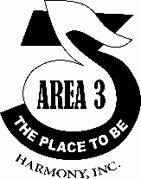

-7-

