AREA 3 CONVENTION & CONTEST

MAY 1-3, 2020
SYRACUSE - LIVERPOOL, NY

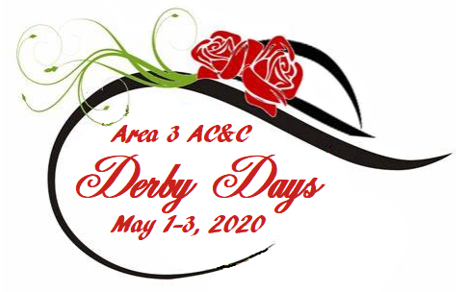

AREA 3’s A.C.C.T. [Area Convention & Contest Team]

and Hostess Chapter, CRYSTAL CHORDS,

Welcomes You To:

“DERBY DAYS”

This 1st mailing provides members with important information. Please read fully for details:

*Page 2 = Hotel Information

*Page 2 = Contest Registration

*Page 3 = Contestant General Information

*Page 4 = TENTATIVE Weekend Schedule & MBHA Information

*Page 5 = Area Chorus / Quarus / Family Song Information

*Pages 6-7= Hostess Chapter Information

*Page 8 = Moonglow / Program Ads

More details will follow in the 2nd mailing in early April. Questions? Please email ACCT:

Dorene at: acctchair@area3harmony.org

AC&C 2020 HOUSING
Please complete & return an email copy, if mailing a hard copy, it must be postmarked by MARCH 20, 2020
to: Dene Day 1065 Latta Road, Rochester, NY 14612
[email: facilities@area3harmony.org]
Hotel: Holiday Inn Syracuse-Liverpool & Staybridge Suites, 441 Electronics Parkway, Liverpool, NY 13088. Room costs are: $129.00 [single/double or triple/quad]
**NOTE: Staybridge Suites guests already have their room prices as these rooms were booked in December!

Individual reservations will NOT be accepted. Using the pre-printed Housing Form, add the rest of your members accordingly.

All choruses will receive an emailed 2020 AC&C Housing form, prefilled with the people in their chorus that have already booked suites. Return that ONE completed Housing Form with the rest of the people in your group. Please, no handwritten forms; they can be very hard to read. Each chapter/quartet contact must provide a contact email for questions. A list of occupants in each room is required; be sure to indicate any special needs. The form allows for chapter credit cards so, if you pay with a Chapter credit card, ONLY this is needed to hold reservations. Reserved cards are imprinted at check in.

NYS choruses may submit a Tax Exempt ST-119 Form, along with their Housing form. ALL rooms under the exempt status for that chorus need to be paid by a chorus credit card or cash. A debit card attached to a chorus checking account or cashier’s check is recommended. (NO tax exempt status for individuals.)

Parking on-site at the Holiday Inn Syracuse-Liverpool is FREE. There is an on-site restaurant and excellent amenities such as an indoor swimming pool, fitness room, & complimentary high speed internet access. The hotel is also attached to the Staybridge Suites Hotel, where many members have booked suites. There are some retail stores and food services nearby as well!
Please, ALL reservations are to include the following information. Thank you!
- Name[s] for all occupants of each room, also include room type.
(single/double, trip/quad). This is a NON-SMOKING HOTEL.
- Credit card type to be used for payment, including number & expiration date – this is required only for the purpose of ‘holding’ the reservation…
- Arrival Date & Departure Date [check in is 3PM ~ check out is by 12 noon]
=================================================================================

AC&C 2020 REGISTRATION [AEP]

Contest Site: Holiday Inn Syracuse-Liverpool – CONVENTION CENTER [attached]
As last year, our contest location is THE SAME as our HOUSING venue!! Just as we do at IC&C, we are conducting all AC&C 2020 events under one roof! The Convention Center is part of the Holiday Inn!
Please complete & return an email copy, if mailing a hard copy, it must be postmarked by MARCH 20, 2020
To: Michelle Buckenmeyer, 59 Autumn Chapel Way, Rochester, NY 14624 [parliamentarian@area3harmony.org]
Full AEP for AC&C 2020 is $125.00
Non-Performing AEP costs $95.00
Youth AEP will cost $103.00 [covered by HARMONY INC.]
**AEP prices include Judges Equalization Fee from Harmony Inc. & continue to include $37 MoonGlow dinner!

General Admission tickets can be purchased by family members, friends, or guests for $20.00 per event. ALL HARMONY MEMBERS MUST PURCHASE EITHER AN AEP OR NP AEP. *NOTE: AEPs are transferable, not refundable. All choruses / associates must complete this form whether or not you are competing...
*PLEASE be certain all registered names are spelled correctly so that AEP badges are accurate. Complete the names in alphabetical order for each member attending, & list the appropriate AEP price. Also include known guest names and money for any tickets being purchased [$20] or dinners [$37] Note: This allows guest seating with a chorus you registered with
*PLEASE return the Registration Form as an MS Word file. Then names and the chorus/quartet you are associated with are submitted accurately and will be printed on the AEPs exactly as entered on the form! Mail a copy of the form with ONE payment CHECK to Michelle made to: Area 3, Harmony, Inc. Please return paid AEP Registration Forms ASAP!
*NOTE: Reminder, receipt order of AEP/Registration determines priority MoonGlow seating!*
-2-

AC&C GENERAL CONTESTANT INFORMATION: It's time for all contestants [chorus & quartets] to complete and send in their Contest Entry Forms. Please complete the forms (HAR-061 or HAR-063) found on the Harmony Inc. website, Members Only section.

Contest Entry forms must be postmarked no later than March 2, 2020, in order to be a part of the initial draw for the Order of Appearance for either the Quartet or Chorus Contest. If you miss this date, a late fee will be assessed and you will sing first in the applicable contest. In order to compete, your late entry must be postmarked no later than April 1, 2020.

The AC&C 2020 JUDGING PANEL will be: Marie Ross – Chairman of Judges; Linda Briggs – Associate COJ
Music Category: Janet Billings & John Burri
Performance Category: Fatima Whelan & Steve Curulla
Singing Category: Wendy McCoole & Jen Wheaton Forest
===============================================================================
Schedule Changes: In order to avoid overlap with chorus rehearsals, the rehearsal times for the Area 3 Chorus and Family Chorus have been changed. These rehearsals will now take place early Saturday morning before chorus rehearsals.
The Chorus on-stage viewing time will now be on Friday evening after the Quartet contest.
*These schedule changes were made based on feedback from last year.*
Chorus Photo: CHORUS photos will now be taken in a separate room and be part of the contest pattern.
Quartet Heads-up: Please note that the Quartet Contest time is tentative (Friday 3:00pm). We may have to start earlier depending on the number of quartets that might be competing. We will not know this until all entry forms have been submitted. Please consider coming Thursday night, if possible, so you can enjoy contest day without being rushed!
Quartet Heads-up 2: Quartets, please remember that there are no classrooms or warm-up areas, so you will need a hotel room to get ready in. Please don’t leave it until the last minute to figure this out. If possible, try and come Thursday night so you have a room, or see if a chorus member is coming on Thursday who will allow you to use her room.
=================================================================================
VOLUNTEERS
We need lots of help over the weekend in order to put on a successful AC&C. Please consider volunteering for a job on contest weekend.
Here is the link to the Sign-Up Genius volunteer sheet.
https://www.signupgenius.com/go/10c0f45aaaa2fa6f85-area
If you have any questions, please contact Anne Leinen (barileinen@gmail.com) – Crystal Chords volunteer coordinator, or Nicola Stevens (a3jc@area3harmony.org)
-3-

CONTEST STAGE INFORMATION:
The contest stage setup will be the same as last year. There will be six risers, six foot, four-step risers, (same as last year). You will enter stage right via the ramp, and exit stage left via the stairs (unless the ramp is needed). Again, there will be NO stage curtain. Each chorus package starts when the director signals the emcee for the introduction. Quartet packages begin when the emcee introduces each quartet. As noted above, chorus photos will now be taken in a separate room, NOT on the stage.

********************************************************************************************
------------------------------------------------------------------------------------------------------------------------------------------
TENTATIVE WEEKEND SCHEDULE ~ AC&C MAY 1-3, 2020
DATE | TIME | SCHEDULE | ROOM/FACILITY
Friday, May 1 | 10 AM – 3.30PM | Registration | Convention Center Foyer
 | 10 AM – 1.30PM | Hospitality | Ballroom East
 | 12:30 PM – 1:00PM | Area Quarus Rehearsal | Cotillion 1
 | 1:00PM – 1:30PM | Contestant Judges Briefing | Convention Center
 | 1:30PM – 2:15 PM | Quartet on-stage viewing | Convention Center
 | 3:00 PM - 7:00 PM | Quartet Contest: Area Quarus, Awards & Qualifiers, 1st place sings | Convention Center
 | 7:30 PM – 8:30 PM | Chorus on-stage viewing (no singing) | Convention Center
 | 8.00 PM – 11.00PM | Evaluations | TBA
Saturday, May 2 | 8AM -10:30 AM | Hospitality | Ballroom East
 | 8:00 AM – 8:30 AM | Area Chorus Rehearsal | Convention Center
 | 8:30 AM – 9:00 AM | Family Chorus Rehearsal | Convention Center
 | 9:00 AM – 11:00 AM | Chorus Rehearsals | TBA
 | 10:00 AM - Noon | Registration | Convention Center Foyer
 | Noon – 2:45 PM | Chorus Contest: Area Chorus, Awards & Qualifiers, 1st place sings | Convention Center
 | 3:15 PM – 5:30 PM | Chorus Evaluations | TBA
 | 6:30 PM – 8PM | Cocktails / Dinner | Convention Center
 | 8PM – 10:00PM | MoonGlow | Convention Center
Sunday, May 3 | 9AM – 12:30PM | Education / Craft Classes | Cotillion 1, 3 & Ballroom West
 | 9AM – 11AM | Hospitality | Ballroom East

NOTE: This is a TENTATIVE SCHEDULE ONLY. The Chairman of Judges (COJ) will give the FINAL approval late April, 2020. AGAIN – these times and locations are NOT final!!
========================================================================
Harmony Welcomes Mixed Quartets!

We’re happy to again announce that Areas 1, 2, 3, 5 & 6 have opened their arms to include mixed quartets registered with the Mixed Barbershop Harmony Association (MBHA) in this spring’s Area Conventions. These Areas invite mixed quartets of any makeup – MWWW, MMWW, MMMW – to experience the joy of a Harmony convention first hand and to be adjudicated at the AC&C.

For details on how to register with MBHA visit: www.mixedbarbershop.org. Once you are registered with MBHA and your dues are up to date, please complete the Quartet Contest Entry Form (HAR-061).
https://www.harmonyinc.org/har-061-official-area-quartet-contest-entry-form/). If you need assistance, please contact Nicola Stevens, ACJC (a3jc@harmonyinc.org). All contestants must purchase an All Events Pass [AEP] for the Area Convention & Contest. All Contest Entry Forms are due by March 2nd.

-4-

AREA 3 CHORUS:

Katie Taylor is leading our 2020 Area 3 Chorus in song at this year’s AC&C, as the director from Northern Blend, our 2019 Area 3, 1st Place Chorus Champion. The song is “Change the World”, arranged by David Wright / Deke Sharon.

Traditionally, the Area Chorus has been made up of 4 singers from each chapter but has not always been limited to that. If you are able to be in the Area 3 Chorus, PLEASE be certain to do your part by LEARNING the song. We will continue with our annual AC&C Saturday morning rehearsal and performance Saturday afternoon at AC&C. Remember that all Area 3 Associate members [in good standing] are also invited to sing in the Area 3 Chorus! The Area 3 Director will send out 4 copies of music and trax to each chorus. Associates and any other member interested in singing may contact Janine Schindler, Area 3 Director at:area3director@harmonyinc.org.

AREA 3 QUARUS:

Our Area 3 Quarus Directors for 2020 is Harmony, Inc. 2018 Queens, Aged to Perfection, and the song the Quarus will be singing is, “Go the Distance”, arranged by Aaron Dale. Sheet music and learning trax will be available to registered quartets soon, once you decide that your quartet can learn this song and be with us for the Friday afternoon rehearsal and performance Friday evening at AC&C. Please email the Area 3 Director, Janine Schindler, area3director@harmonyinc.org for music and trax.

AREA 3 FAMILY CHORUS:

This is an invitation to all Area 3 singers who fall within the FAMILY category to please participate in our Family Chorus at AC&C 2020! This year’s director will be Anne Bureau and the song she has chosen is “When There’s Love at Home”, arranged by Tom Gentry. We certainly don’t want to miss anyone who is eligible to enjoy this experience and encourage all members who have a mother, mother-in- law, daughter, daughter-in- law, sister, sister-in- law, aunt, cousin, associate member and/or affiliate male family member that sing in Area 3 – to please join us! It is a very enjoyable and rewarding experience.

Please indicate your interest in participating by emailing Janine Schindler, the Area Director at: area3director@harmonyinc.org, and she will send you the music and trax. We’ll continue with our annual AC&C Saturday morning rehearsal and Saturday performance at AC&C so that we may have some time together prior to our performance.

-5-

AC&C 2020 Hostess Chapter, CRYSTAL CHORDS, presents:

“DERBY DAYS”

--------------------------------------------------------------------------------------------------------

The Crystal Chords are so excited to welcome Area 3 back to Liverpool as we ”Call to Post” for our exciting Derby Days. The stakes are high as we all pony up to the starting gate and find out who will win, place, or show in the big Sweepstakes. You can bet there will be plenty of harmony, friendship, and fun as we cheer each other on.

For those photo finishes, there will be a photo area at the Moonglow to capture the moment with pictures and selfies, so be sure to wear your finest Derby Hats!!

We have beautiful t-shirts with the Derby Days logo available for pre-order (see t-shirt order page). These are available in two colors -- ‘Carolina Blue’, and ‘White’ -- in sizes XS – 4XL, for $15 each.

There will be plenty to peruse in the Hospitality Room too, so be sure to stop in – credit cards will be accepted! If your chorus or quartet would like to reserve a table in the Hospitality Room to sell your CDs, please be sure to contact Chris Dunbar at cdunbar419@gmail.com.

-6-

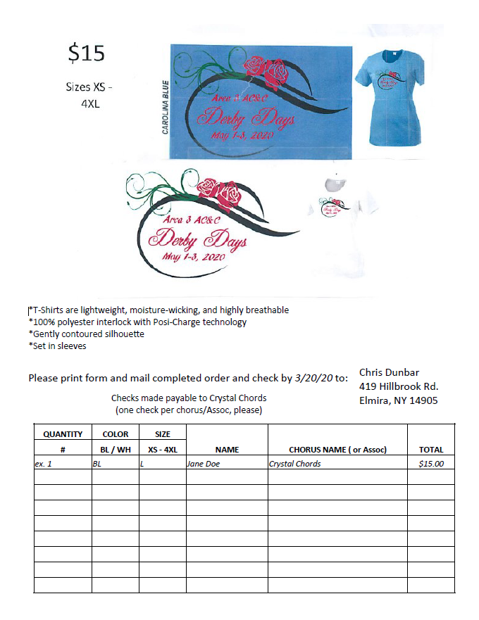

-7-

~~~~~~~~~~~~~~~~~~~~~~~~~~~~~~~~~~~~~~~~~~~~~~~~~~~~~~~~~~~~~~~~~~~~~~~~~~~~~~~~~~~~~~~~~~~~~~~~~~~~~~~~~~~~~~~~~~~~~~~~~~~~~~~~~~~~~
Reminder -- For the MoonGlow, other than the normal pre-determined awards being presented, only the following will be part of our Saturday evening annual Area 3 AC&C MoonGlow program:
- ALL Choruses -- will perform one song [unless an exemption is requested]
- ALL Area 3 Current Quartet Medalists -- will perform one song
- ALL Area 3 Queen quartets and/or International Chorus Champions -- will perform one song [unless they do not wish to do so]
- Judges -- will perform one song [unless they elect not to do so]

----------------------------------------------------------------------------------------------------------------------------------------------------------------------

-*PROGRAM ADS*: Again, we’re offering choruses/quartets the chance to purchase PROGRAM ADS. Choruses / quartets may wish to send out congratulations or good luck wishes to contestants or new members in a program ad!

If you would like to do so, please send the ad copy to our Area 3 Publicity Coordinator, Cait Schadock, pr@area3harmony.org by MARCH 30th
- NO LATER!

Send payment with check made out to: Area 3, Harmony, Inc.
to: Ann Christiano, AREA 3 TREASURER,
125 MARWOOD RD.
ROCHESTER, NY 14616

PLEASE ~ your email subject line should read: ACC2020 PROGRAM AD!

If you have any questions, please be sure to ask Cait!
=================================================================================
Program AD Costs --
$15.00 – ¼ page; $25.00 – ½ page; $50.00 – full page

**Look for more information on the Area 3 website at http://www.area3harmony.org

-8-

