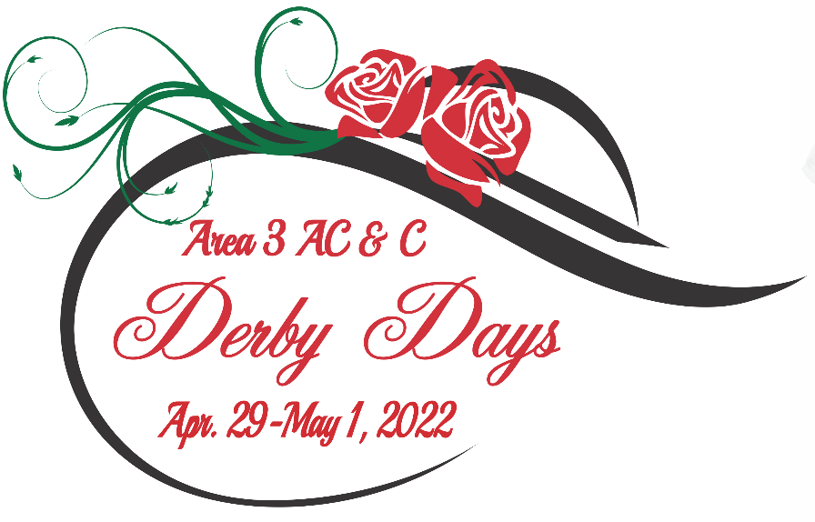

We’d love to have you join us and cheer on our fantastic quartets and choruses for Derby Days! Single-event tickets are available at the door for $20 per contest.

Quartet Contest – Friday, April 29 at 1pm

Chorus Contest – Saturday, April 30 at 12 pm

Area 3 Convention and Contests are a COVID-compliant event

All guests are asked to sign a COVID-19 acknowledgement form, show their vaccine card at the door and wear a 3-ply, medical grade mask at a minimum
(no cloth-style masks are accepted).

